Sprint 1 - Endurance Design Document

March 23rd, 2023

Table of Contents
1. Executive Summary 3
1.1 Project Overview 3
1.2 Purpose and Scope of this Specification 3
2. Product/Service Description 3
2.1 Product Context 3
2.2 User Characteristics 3
2.3 Assumptions 3
2.4 Constraints 3
2.5 Dependencies 4
3. Requirements 4
3.1 Functional Requirements 5
3.2 Security 5
3.2.1 Protection 5
3.2.2 Authorization and Authentication 6
3.3 Portability 6
4. Requirements Confirmation/Stakeholder sign-off 6
5. System Design 6
5.1 Algorithm 6
5.2 System Flow 6
5.3 Software 6
5.4 Hardware 6
5.5 Test Plan 7
5.6 Task List/Gantt Chart 7
5.7 Staffing Plan 7

Executive Summary

Project Overview
Sphereo is an introductory program intended to introduce the user to basic procedural programming and implementing code that results in physical action being taken. Being a basic robotics program, the project is intended to give a surface-level understanding of robotics and programming that will be built upon with subsequent lessons.

Purpose and Scope of this Specification
In scope
- Creation of an algorithm that successfully runs the designated course
- Clean code will be provided that can be expanded upon for the next triathalon events
Out of Scope
- Making a program that exceeds the limits of the Sphereo hardware, by exceeding its maximum speed, endurance, etc.

Product/Service Description

Product Context
This product will demonstrate how Bluetooth can be utilized with creative hardware to create a new learning experience. The interface with which to plan out the algorithm is hosted within a phone app, and communicates with the sphere robot remotely. This Sphereo project relies on several already existing systems in order to function.

User Characteristics

One person utilizing this data would be an introductory computer science student, whom would use this product as a jumping-off point for further research into how robotics is coded. Little technical expertise is needed to utilize Sphereo, and thus the barrier of entry is low for anyone looking to learn from the algorithm. Block code provides this user with easy to understand building blocks for a deeper understanding of designing an algorithm.

Another type of person utilizing this product would be an instructor, either utilizing it as an example to share with future classes, or a method of judging the developer’s progress within the class. Knowing much more about computer science, the algorithm could potentially help the instructor in future lectures by providing a personal, organic result of their teachings.

Assumptions
Iphones and laptops capable of running Sphereo software will be available at all times. Bluetooth connectivity between developing hardware and the sphere will be present at all times. The operating systems for which our iPhones and laptops run on will be intact and running whenever needed.

Constraints
- Mac and iphone can get full data, including the motion chart, while normal pcs cannot.
- Time restriction is until the 23rd of March, 2023
- Triathalon algorithm must be easily shared between both developers, and agreed upon when finished.
- Framework must be concise before developing final algorithm.
- Speed must be implemented after a functional algorithm is developed

Dependencies
- Sphereo, as well as the operating system it runs on, must be updated to the latest versions.
- This product will require a download from Github
- The user must know how to translate the algorithm into the Sphereo progam.

Requirements

Functional Requirements
Req# | Requirement | Comments | Priority | Date Rvwd | SME Reviewed / Approved
ENDUR_01 | Roll At 88 Speed | Approved. All Rolls and Turns at 88 Speed with except of 1 (180 Degrees) | High | 03/07/2023 | Approved
ENDUR_02 | Travel Through Course Without Hitting Obstacles | Approved and Discussed of how we will make it work | High | 03/07/2023 | Approved
ENDUR_03 | Robot will return to the Starting Point | Approved and Discussed | High | 03/07/2023 | Approved
ENDUR_04 | Turn Right 90 Degrees Per Turn throughout the Obstacle Course | Approved. At every turn Robot will turn 90 Degrees More (90,180,270) | High | 03/07/2023 | Approved

Security

Computers containing Data required to use the robot will only be in personal devices (Victor and Jack’s Computers).

Protection

All data will be saved locally, and confined to two flash drives containing all of the data. A VPN will be used to ensure computer security is not breached.

Authorization and Authentication
Only Jack and Victor are authorized to work on this assignment. Authentication will involve solely working with each other on the project

Portability
Code will be posted to github, making it easily downloadable for anyone looking for an introduction to Sphereo.

Requirements Confirmation/Stakeholder sign-off
Meeting Date | Attendees (name and role) | Comments
03/07/2023 | Victor and Jack | Collaboration on algorithm, as well as sharing of ideas for development. Confirmed basic ideas
03/19/2023 | Victor and Jack | Algorithm confirmed, testing in next few days
03/21/2023 | Victor and Jack | Video taken, successful application of algorithm

System Design

Algorithm
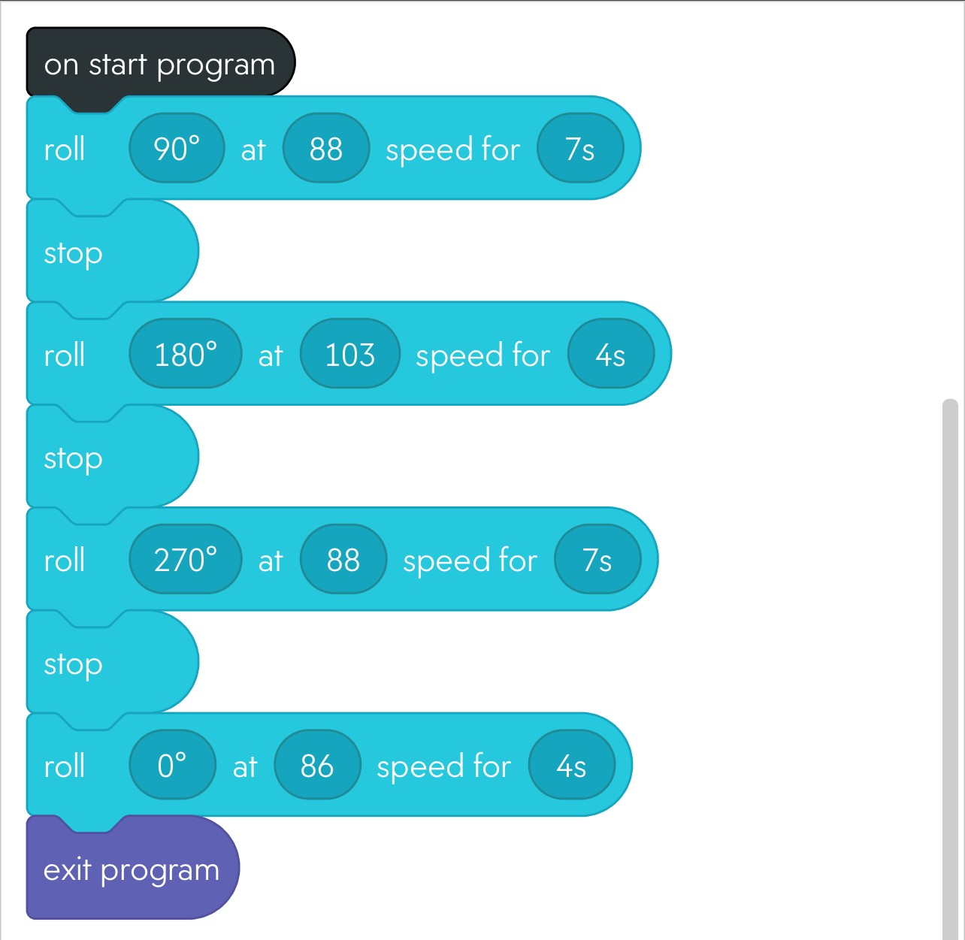

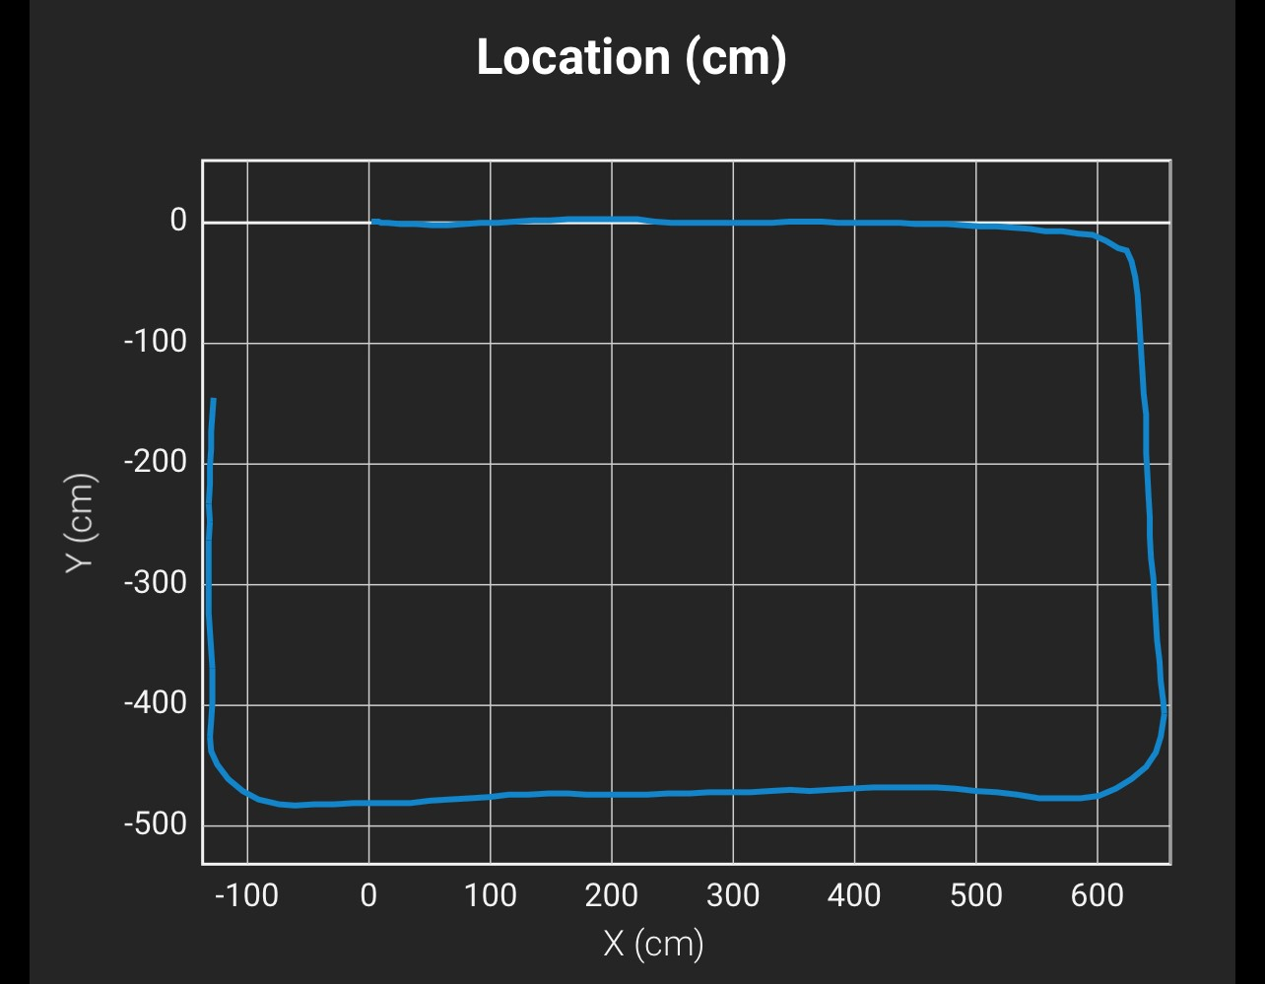

System Flow
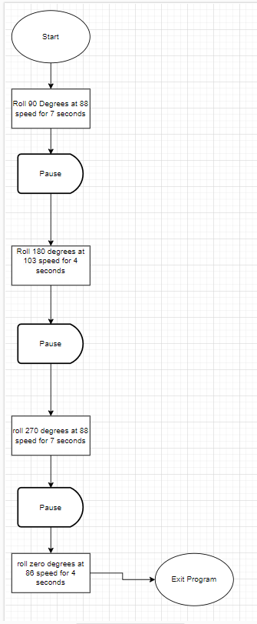

Software
Sphereo’s programming relies on javascript, and is hosted on the Sphereo app. Flowcharting and designing of the program will be done using draw.io

Hardware
A Mac computer, as well as an iphone 12 will be used to develop, test, and apply the algorithm for the entirety of the project.

Test Plan
Include a test plan showing all unit tests performed for this application, Include test rational, test date, staff member, pass/fail status

Reason for Test Case | Test Date | Expected Output | Observed Output | Staff Name | Pass/Fail
To Understand How The Robot Moves | 03/07/2023 | Not Necessarily Expecting Anything, observing how it moves around and getting a idea | Successfully Figured how to favorably move the robot | Victor and Jack | Pass
Changes in the Algorithm | 03/07/2023 | Original Creation of Algorithm | Algorithm needed to be tweaked | Victor and Jack | Fail
Calculating Best Speed | 03/07/2020 | For it to successful make the roundtrip without hitting anything | Was Too Fast to Make accurate turns | Victor and Jack | Fail
Changes in Algorithm | 03/07/2023 | To change the speed in order to make accurate turns possible | The Speed being lowered made more accurate turns | Victor and Jack | Pass
Calculating Best Speed | 03/07/2023 | Lowering the Speed to make accurate turns | Turns were much more accurate then previous attempts | Victor and Jack | Pass
Calculating Turns | 03/07/2023 | Making every turn at an 90 degree increase would work successfully | It did work successfully | Victor and Jack | Pass
Test Run | 03/07/2023 | Final Run to avoid hitting things and run obstacle course efficiently | It passed | Victor and Jack | Pass
Final Test Run | 03/19/2023 | Another Final Run before submission | It passed | Victor and Jack | Pass

Task List/Gantt Chart
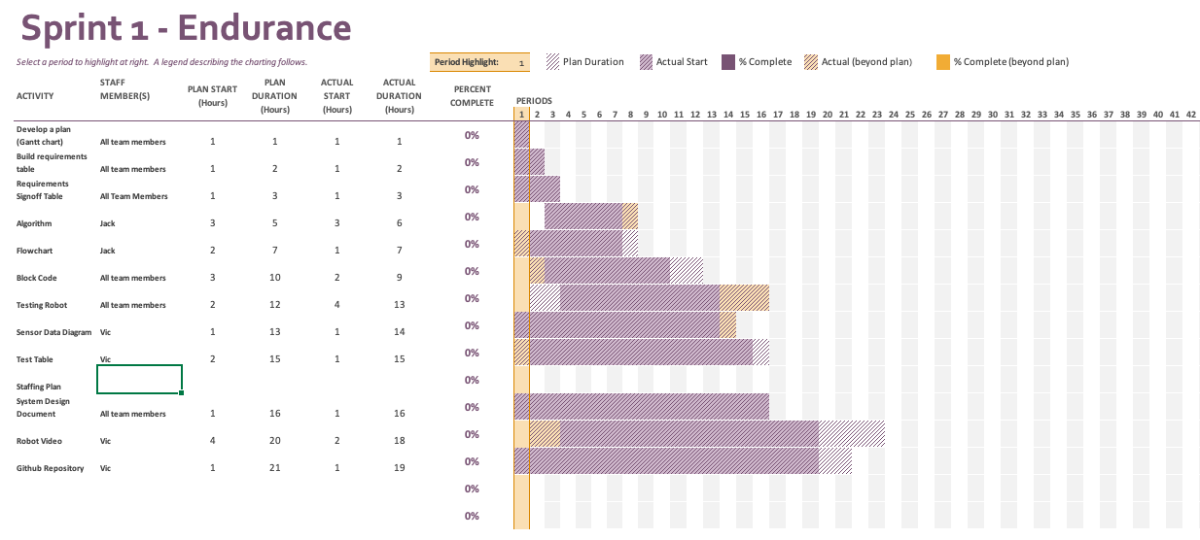

Staffing Plan

Name | Role | Responsibility | Reports To
Jack Miller | Lead Developer | Develop algorithm for Sphereo | Victor
Victor Davidson | Project Manager | Ensure deadlines are met, communications are frequent | Jack

